To install Jenkins we need some pre requisites like Java and Maven.
To install Java-11 : “yum install java-11-amazon-corretto -y”
To install Maven: We can install both way
- Yum install maven – This will install maven version with supported java version automatically.
- You can go to google and run ‘index of maven’ you will get this link from results Index of /dist/maven/maven-3 (apache.org). go to binaries folder and download the package with wget and extract it to your /opt folder.After that set paths for maven like below and run “source maven.sh”.
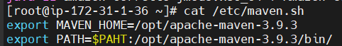
To install Jenkins: go to google search for ‘jenkins.io’ click on documentation select linux and run the steps given.
Link:- Linux (jenkins.io)
After installation allow the port 8080 in AWS. PFB SS.
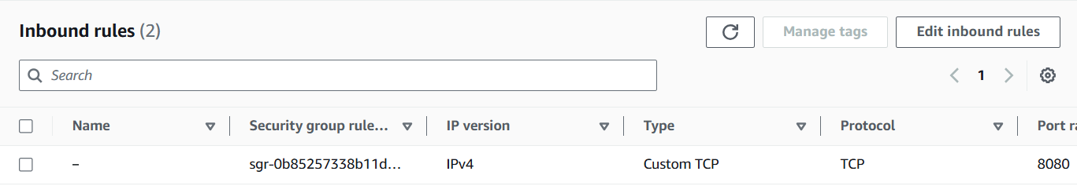
Go to browser and run <public ip>:8080. It will prompt for password collect the encrypted password from the given path from linux machine and submit it. Then it will ask for to create a user. Create a user. That user is Admin user.
First Job:-
Create a pipeline script job and add below script for a demo.
pipeline {
agent any
stages {
stage (build) {
steps {
sh 'echo "build completed"'
}
}
}
}
Configuring the tools:- To configure Jenkins tools first we need to go to Manage Jenkins > Tools > JDK installations
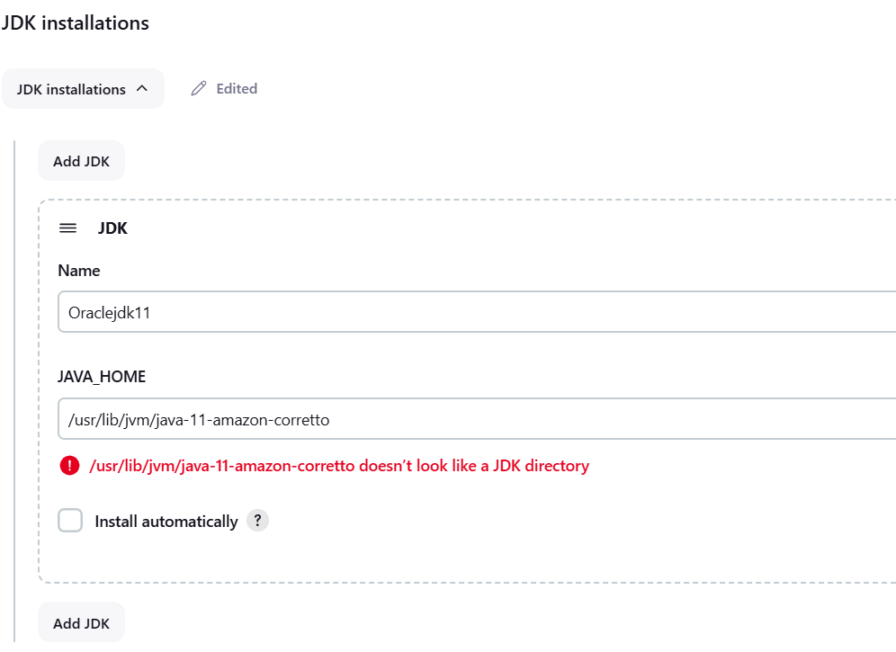
And Maven Installation will be
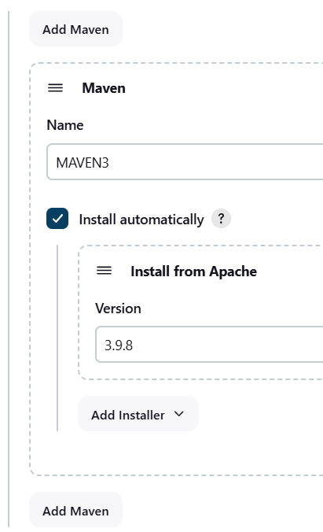
Save it.
Nexus Setup:-
Create an EC2 instance with below inbound rules
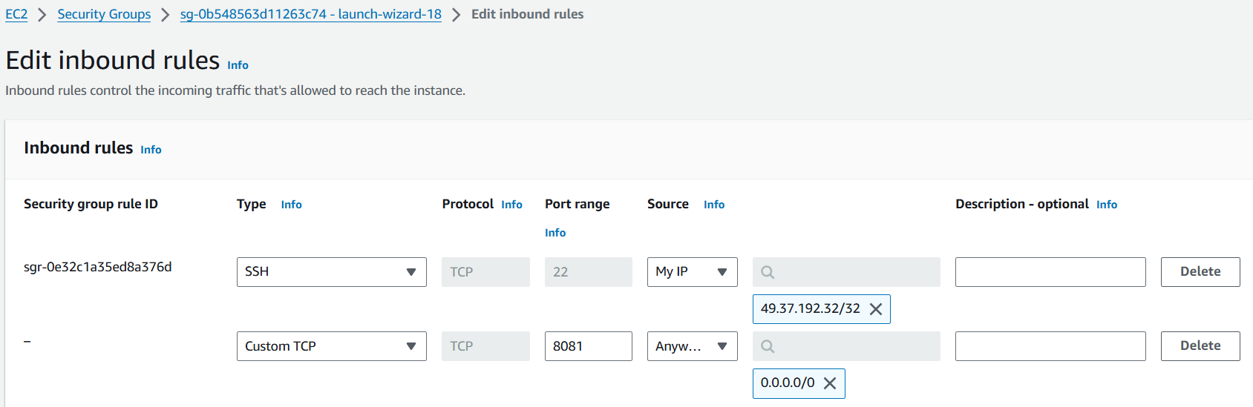
Go to userdata/bootstrap in ec2 instance and add this script vprofile-project/userdata/nexus-setup.sh at ci-jenkins · hkhcoder/vprofile-project (github.com) and submit. After few minutes you can try the public ip with port 8081 on browser. You can see the nexus page click on sign in the username is admin and the password you can find in /opt/nexus/sonatype-work/nexus3/admin.password path and click on submit later next page you can reset the password and give check mark to “enable anonymous access”.
Sonarqube setup:-
Create a new instance with inbound rules of
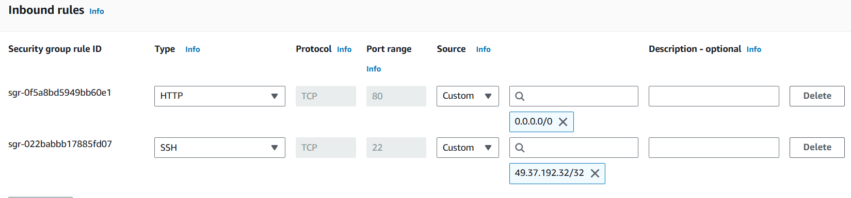
If you are using ‘MY IP’ instead of ‘Custom’ then add Jenkins SG to it. Same for Nexus also.
After that go to userdata/Boostrap add this script vprofile-project/userdata/sonar-setup.sh at ci-jenkins · hkhcoder/vprofile-project (github.com) and click on create instance. After few minutes try on browser with public ip and port 80.
You can see the sonarqube page click on sign in login with user id “admin” and password “admin”.
Plugins to install:-
- Nexus artifact uploader
- Sonarqube scanner
- Git
- Pipeline Maven integration Plugin
- Build Timestamp -> to version the artifacts
- Pipeline utility steps
Pipeline script:-
Create a pipeline with below script and run it.
ddc-material/15.CI-Jenkins/PipelineCodeDemo.txt at master · imnowdevops/ddc-material (github.com)
Note:- Pls write the script on your own if you have any doubts then check the script.
Code Analysis:-
Install sonarqube scanner tool go to Manage Jenkins > Tools > SonarQube Scanner and add
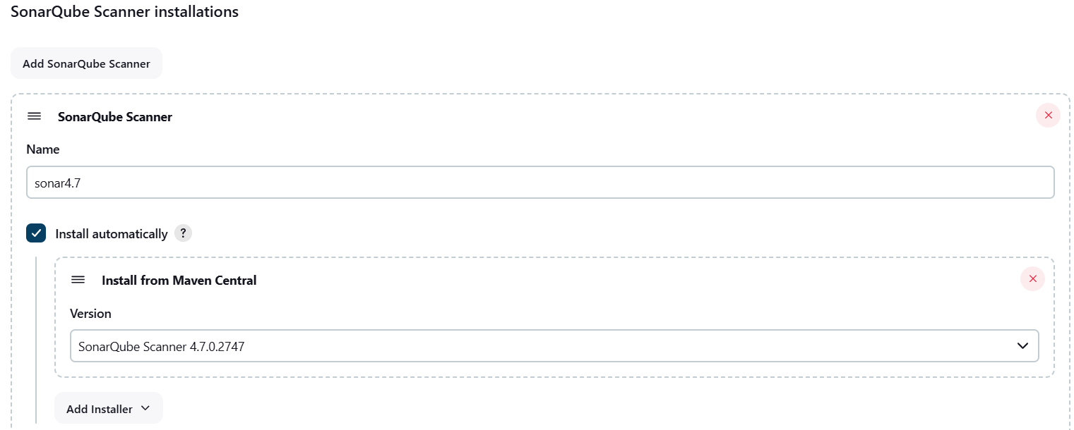
Now go to Manage Jenkins > System > SonarQube Servers
Give check mark to “Environment variables” ,give the name user friendly, “Server URL” will be sonar’s public IP and “server authentication token” you need to get it from SonarQube.
To generate “server authentication token” for SonarQube. Go to SonarQube > profile > My Account > Security > Token give the name of the token and generate it. After generating the token save it somewhere after refresh the page you can’t see the token .
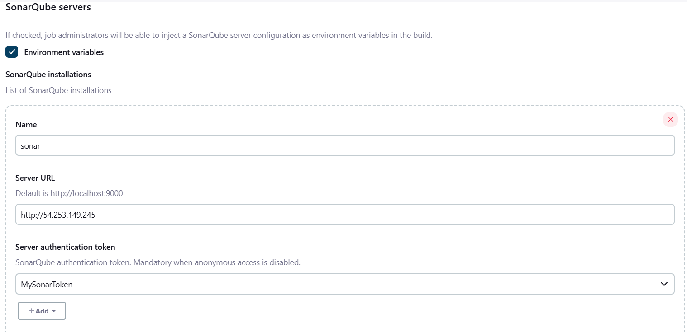

Now create a pipeline job copy below script and run the job.
ddc-material/15.CI-Jenkins/PAAC_Sonar_Analysis.txt at master · imnowdevops/ddc-material (github.com)
It will scan the code and upload it to the sonarqube.
Note:- Carefully read the sonarqube script part like ‘scannerHome’ variable it’s fetching the sonar scanner name manage Jenkins’s tool i.e “tool ‘sonar4.7’”.
Quality Gates:-
To create new Quality Gate login to SonarQube and click on Quality gate, give the user friendly name and give check mark to “all code coverage” and click on create.
I have added the condition with bugs more than 60 will stop the job. As we have already got 82 bugs the job will surely stop.
Now we need add this quality gate to our project go to our project > project settings. Select the created quality gate.
Now Jenkins won’t check whether the Quality gate is created or not but SonarQube will communicate to Jenkins through webhook.
To create Webhook go to project settings > webhooks > create webhook fill the below details.
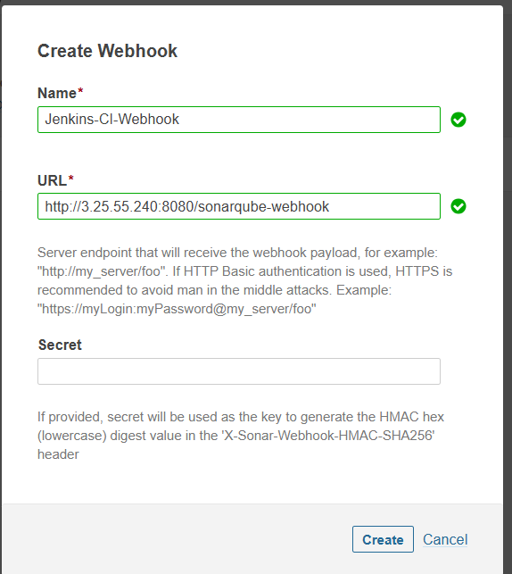
Note:- Name is user friendly, URL is Jenkins private IP:8080/sonarqube-webhook and Secret key not required.
Now, go to Jenkins job add the script ddc-material/15.CI-Jenkins/PAAC_Sonar_QualityGates.txt at master · imnowdevops/ddc-material (github.com) and run it.
You can see below SS from SonarQube the Quality Gate got failed.
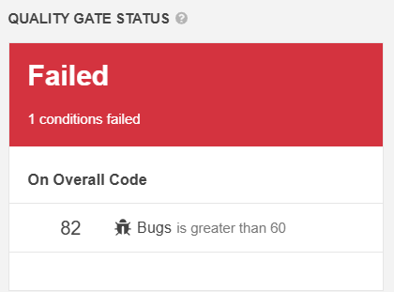
Due to that the job also got failed.Now, If I increase the count of the bugs the job will get succeed.
Nexus Repository creation:-
Login to Nexus go to settings > repositories > Create repository > maven2 (hosted)> give the name and create it.
Maven2 (hosted) :- To store the artifacts
Maven2 (proxy) :- To download dependencies
Maven2 (group) :- to do above both
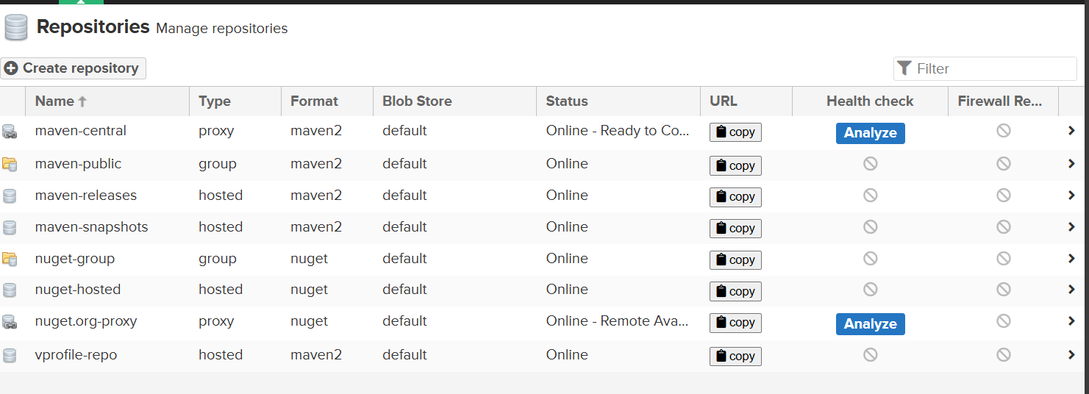
You can see our repo at bottom.
Now, go to Jenkins add Nexus credentials go to Manage Jenkins > system > Global credentials (unrestricted) > Add credentials
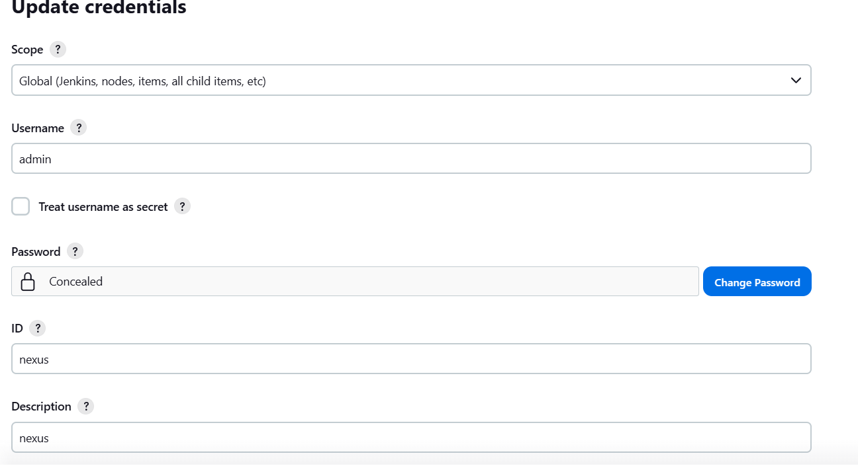
The credentials are admin and 12345.
Now go to Jenkins job add the below script and trigger the build.
ddc-material/15.CI-Jenkins/PAAC_CI_Sonar_Nexus.txt at master · imnowdevops/ddc-material (github.com)
Now you can see that artifacts got uploaded to nexus. To check that go to browse server contents > browse. There you can see our versioned artifacts like below SS.
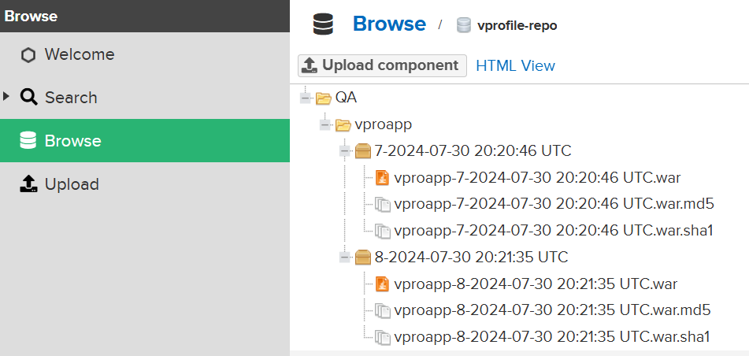
Deploying Artifacts to cloud:-
Pre requisites:
- Install docker engine in Jenkins and add Jenkins user to docker group & reboot
- Install AWS CLI
- IAM user with ECR permission
- Store AWS credentials in Jenkins
- Create repo on ECR
- Need to install Docker Pipeline plugin, ECR plugin, aws sdk for credentials

Step 1:-
Run “yum install awscli -y”
Install the docker for Amazon linux for that use this link Installing Docker to use with the AWS SAM CLI - AWS Serverless Application Model (amazon.com)
After that run “usermod -aG docker jenkins” and the run “reboot”
Step 2:-
Now, create IAM user and ECR repo.
Create the IAM user with below policies, select the option “attach the policies directly”
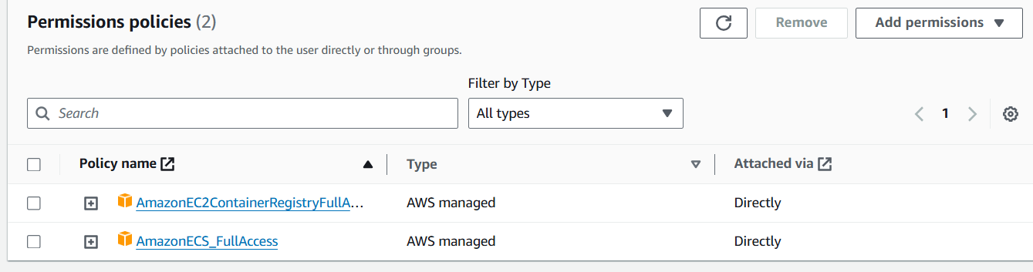
Now go to created user security > create credentials then create and store the credentials file.
To create ECR repo search for ECR > create > select “private repo” and give name > click on “create”
Now, Install the Docker Pipeline, Amazon ECR,Amazon Web Services SDK::All,CloudBees Docker Build and Publish plugins.
Now add the AWS user credentials in Jenkins, you can see the “AWS Credentials” you will see this option if you install the SDK plugin.
Now select the “AWS Credentials” and add user id and token by adding the proper name to the credentials.
Step3:-
Create a new Job and add this script ddc-material/15.CI-Jenkins/PAAC_CI_Docker_ECR.txt at master · imnowdevops/ddc-material (github.com) .
Please verify environment variables. I have modifies the variables according to my project like below.
Note:- Please try to understand the written docker script in Jenkins pipeline script .
After doing that run the job once it is success you can see the artifacts were uploaded to ECR. PF SS below.
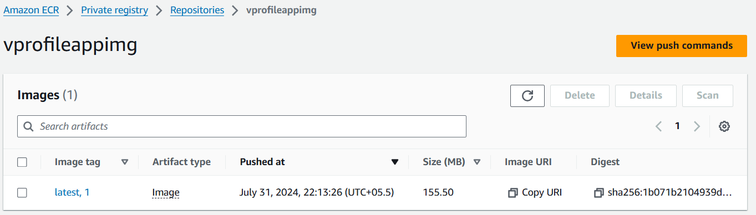

ECS Deploy:-
To do that we need to create
- ECS cluster
- ECS service
- Pipeline: aws steps plugin
Creation of ECS:-
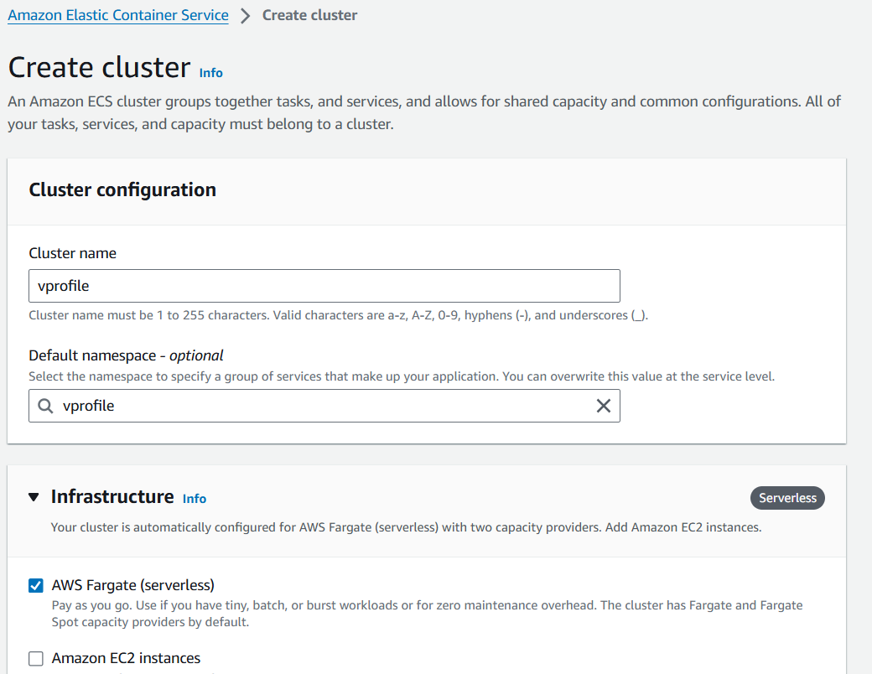
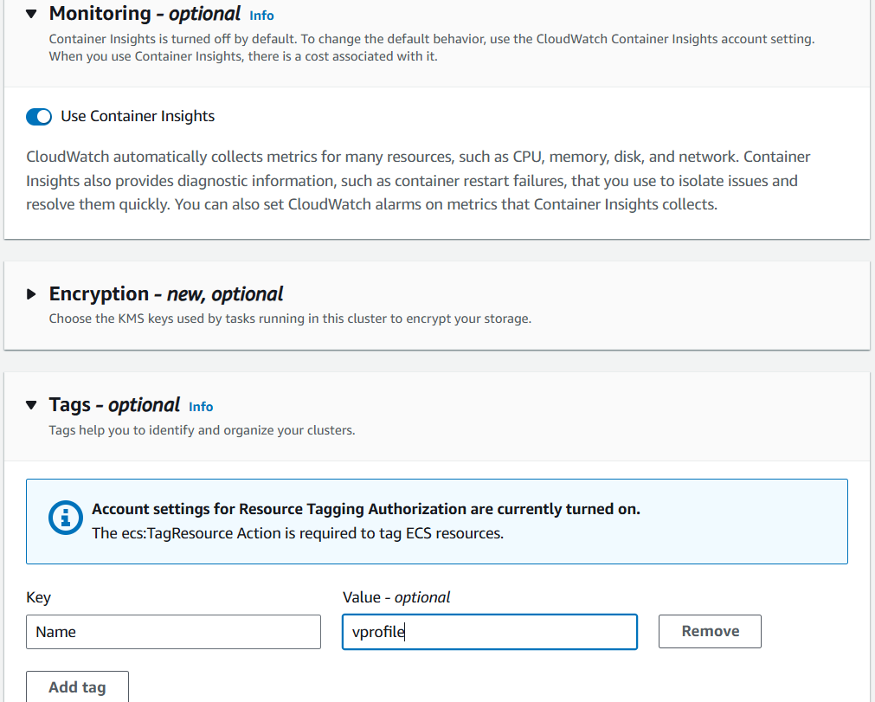
Click on create.
Now we are going to create task definitions. It’s all about your container information according to this template’s info the container will get create.
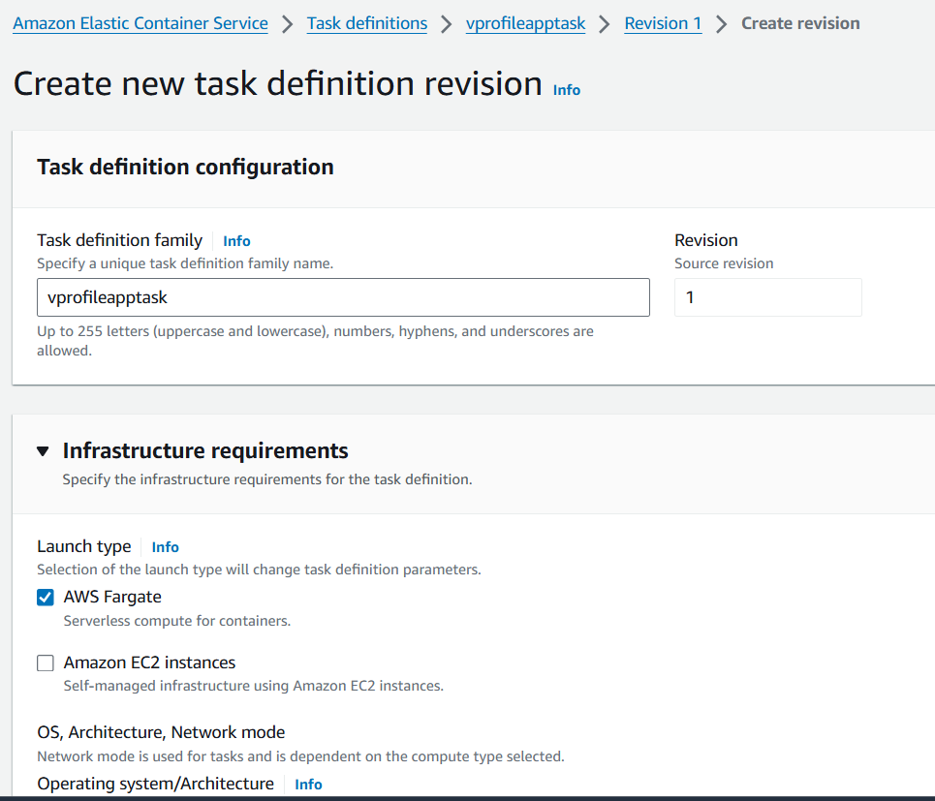
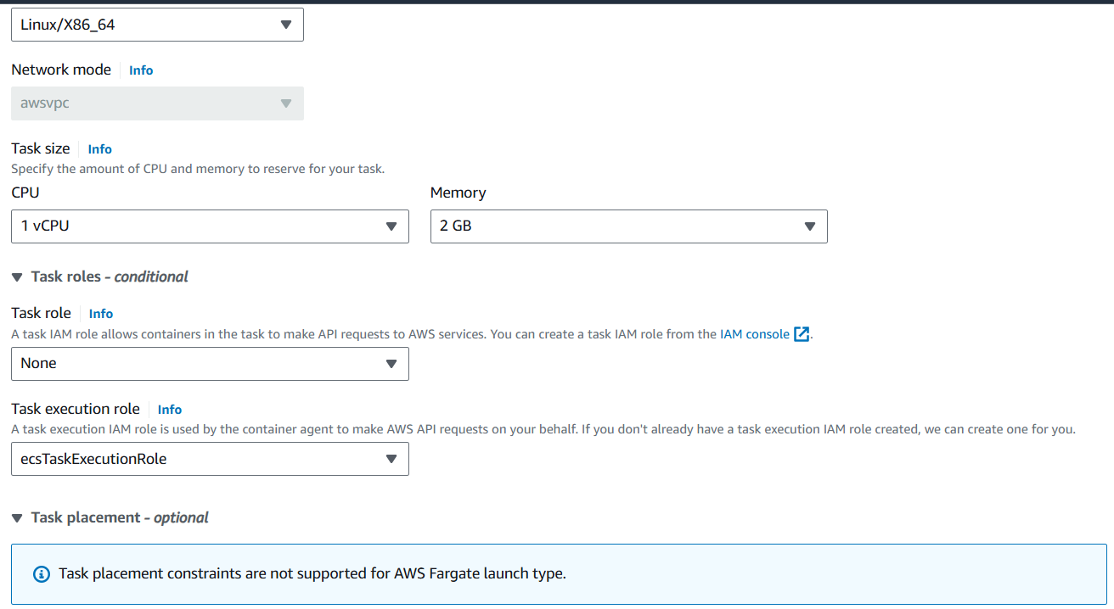
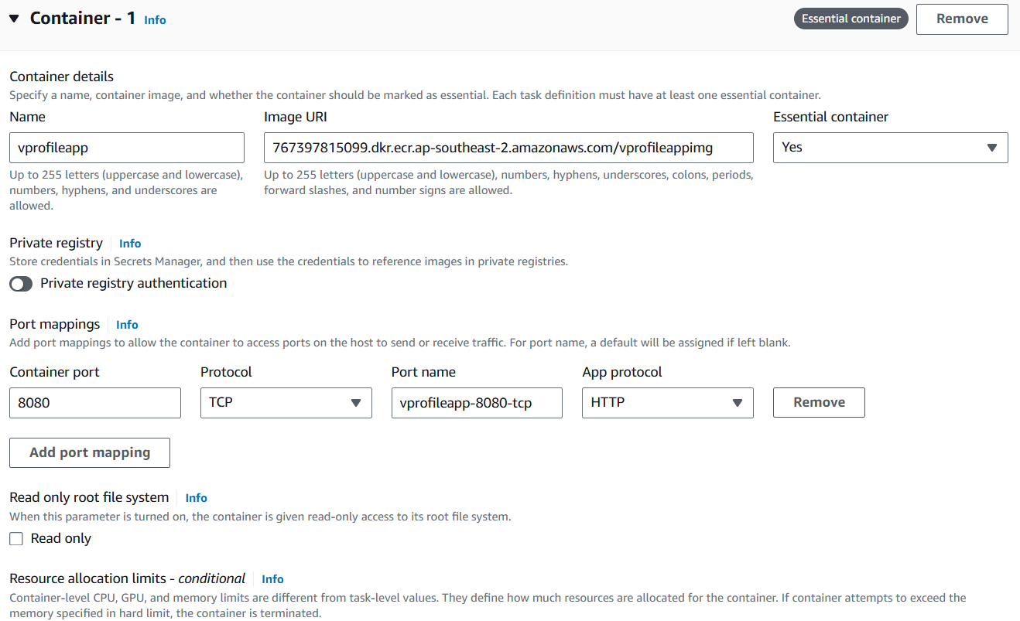
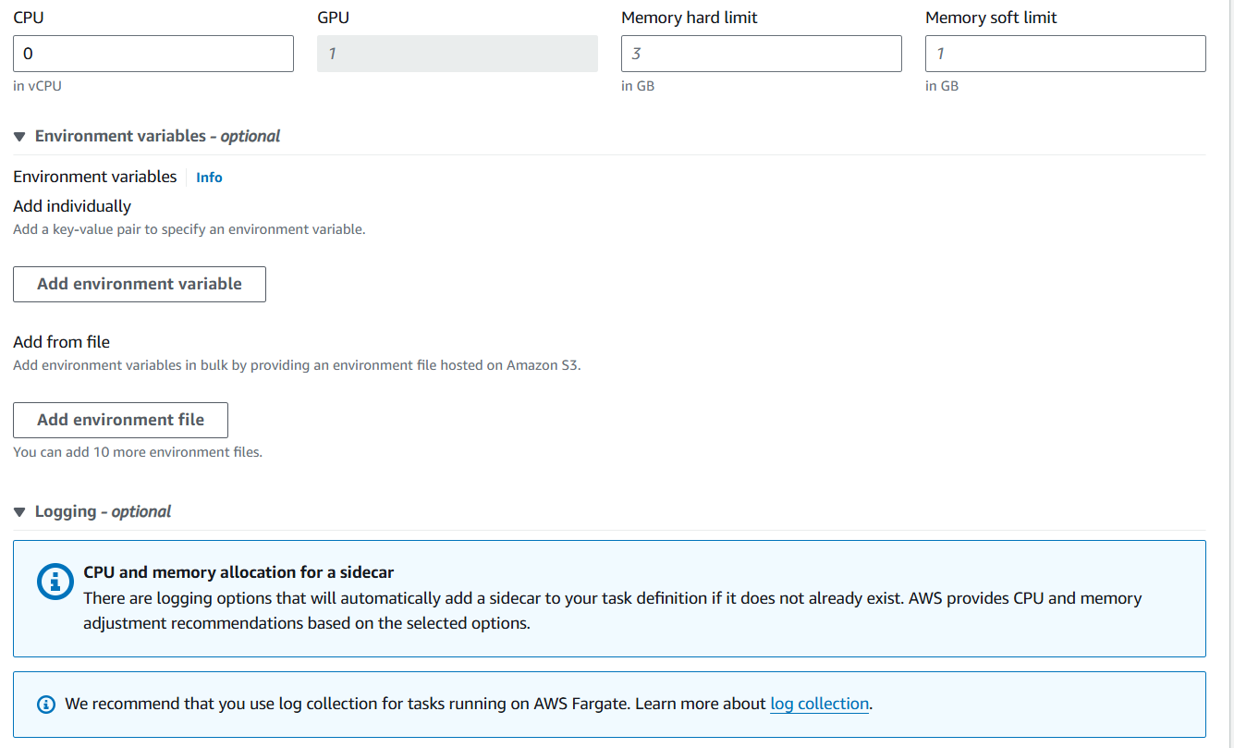
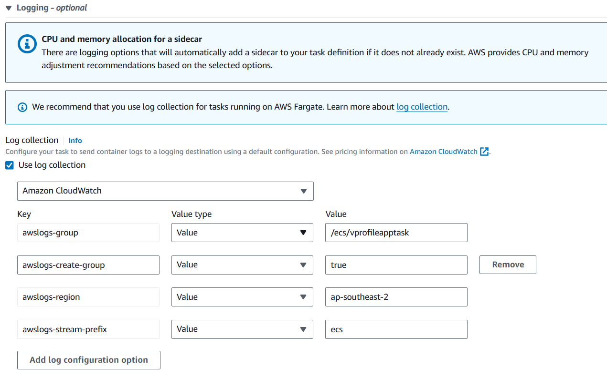
And click on create. Here we need update the role.after creating the task definition you can see “ecsTaskExecutionRole” click on that go to permission policies > click on “Add permissions” drop down > attach policies > attach “CloudWatchLogsFullAcess” policy.
If you don’t have above policy the container won’t get create you will get container get fails.
Now create the service.
Clusters > select the cluster > Services
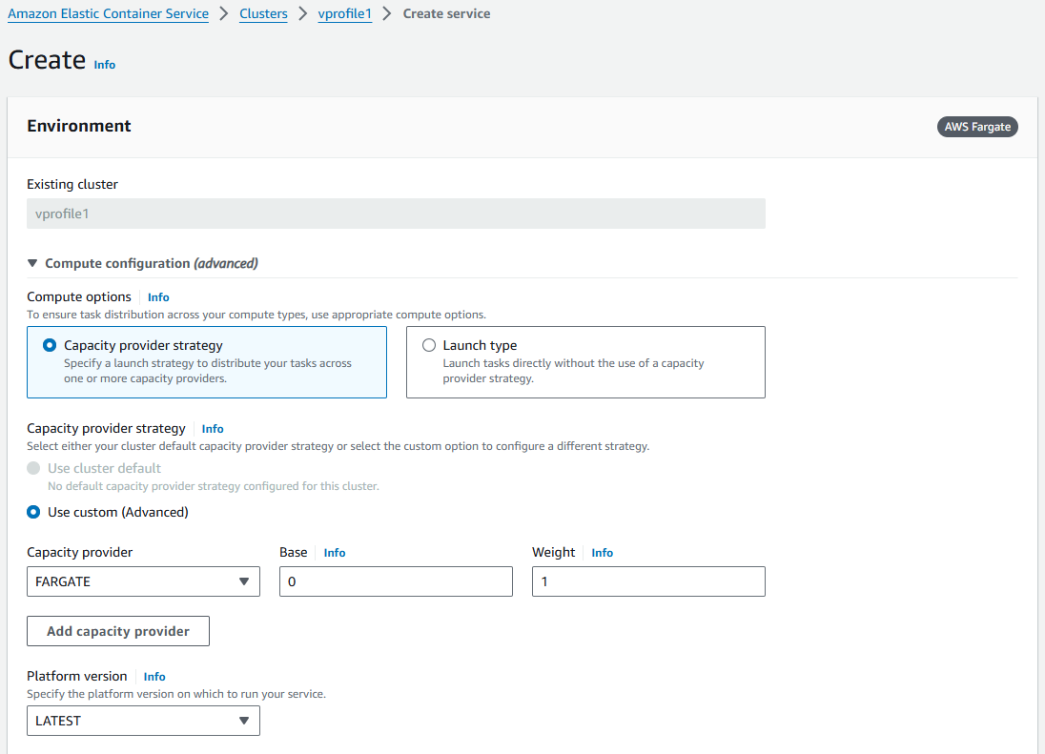
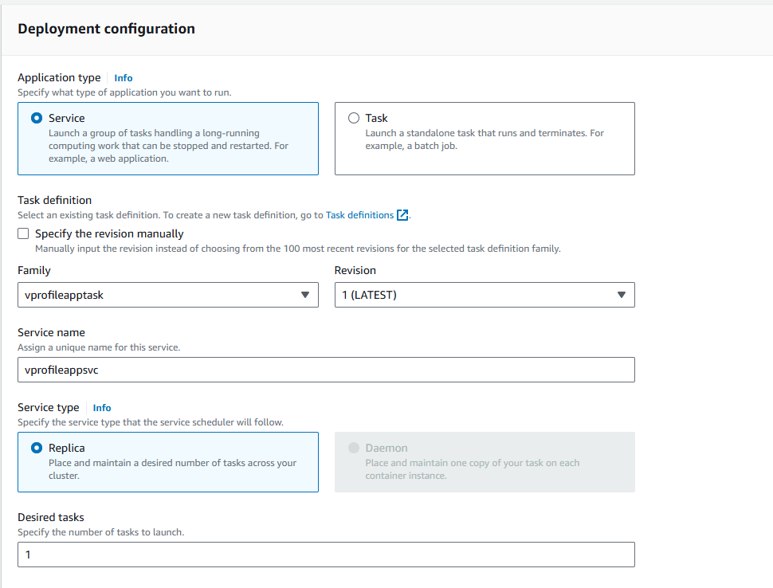
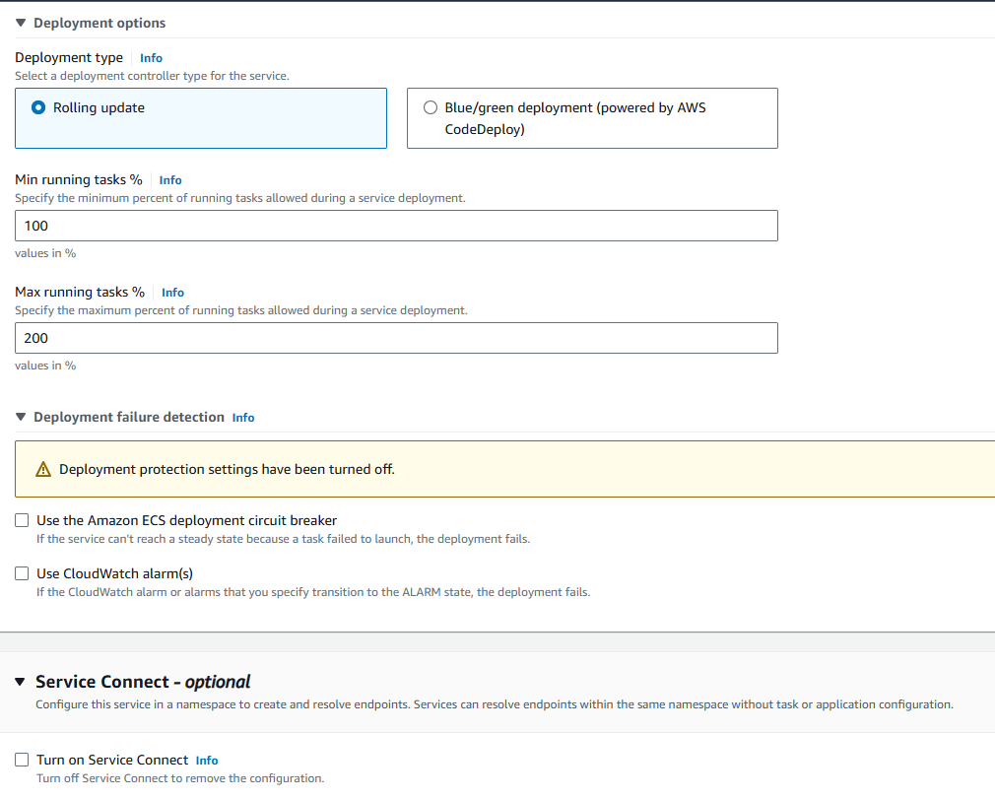
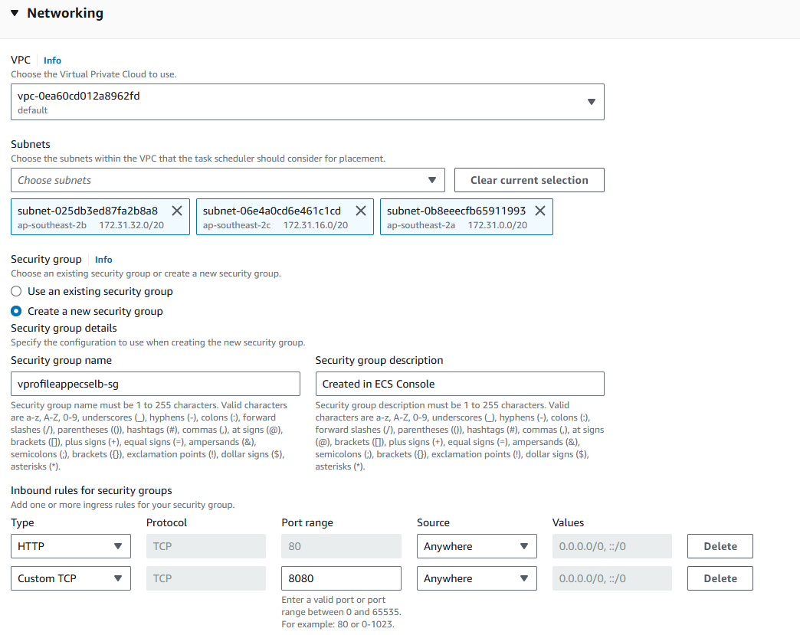
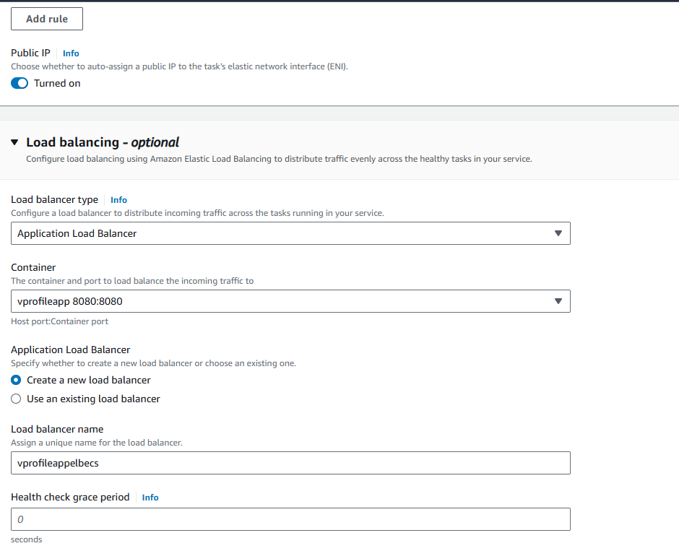
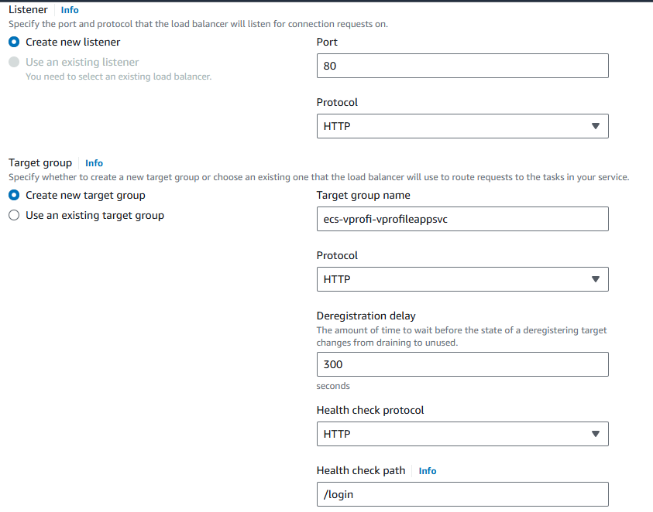
And click on create.
Now my service is created with ELB,TG, it’s running the one container as 1/1 Tasks running
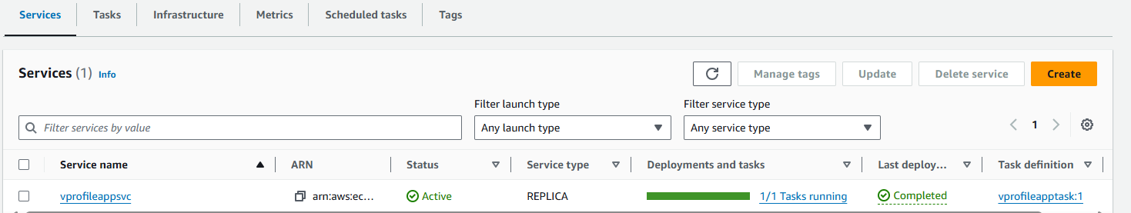
Task you can see the logs
Under “configuration and networking” you can see the DNS name collect it run on the browser you can see your app.
Note:- Taake time see every option of the services and be confortable with it.
Now go to Jenkins and add this script ddc-material/15.CI-Jenkins/PAAC_CICD_Docker_ECR_ECS.txt at master · imnowdevqqops/ddc-material (github.com) .
Please observe the variables this time we have added the ECS cluster and service details.
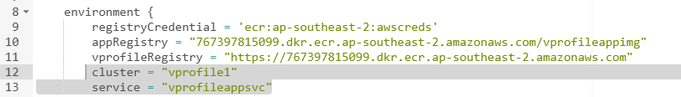
And pls verify the ECS script in pipeline script.
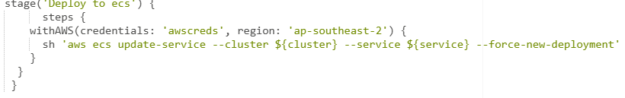
Trigger the build. Go to clusters > your cluster > tasks. You can see the new task getting created click on the task scroll down you can see the containers section there you can see the new container getting created.

